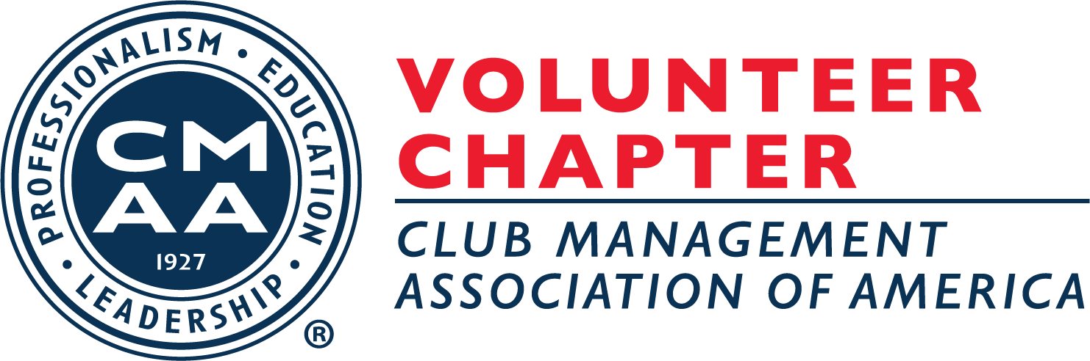

MINUTES OF THE REGULARLY SCHEDULED
BUSINESS MEETING OF THE TENNESSEE VOLUNTEER
CHAPTER OF THE CMAA
MAY 8, 2020

Pursuant to notice duly given, the regular quarterly meeting of the Tennessee Volunteer Chapter of CMAA (the “Chapter”) was held virtually via Zoom on Friday, May 8, 2020.

The following chapter members were present: Chris Almond, CCM, Chris Brown, Kris Garner, CCM, Matt Judge, Michael Murray, CCM, Matt Tornow, Robby Watson, and Shawn Wilkes, CCM. The following guests were present: Bill Boothe, Heather Crutcher, CCM, Miriam Hall, Kevin Walls, PGA, and Dori Paschall, Chapter Managing Director.

President’s Report – Ben Jones, CCM
Dori Paschall, Chapter Managing Director, called the meeting to order at 2:36 p.m. EST. She welcomed everyone to the virtual Zoom meeting.

Vice President’s Report – Michael Murray, CCM
Mr. Murray gave an update on his club, Chattanooga G&CC, and measures they have taken to re-open during the COVID-19 pandemic. The City of Chattanooga shut down all parks, public areas, and golf courses therefore shutting down everything at the club with exception to to-go food orders for three weeks. The to-go food during this time was really successful with nearly 60% of the club’s normal ala cart dining taking place through our to-go options. These options included pantry packages with steak and seafood options, and family meal packages. All were very well received by the members. Golf operations resumed May 1st. The clubhouse also opened on May 1st at half capacity using the Tennessee Pledge for guidelines, taking member temperatures and asking them to wear masks. The taking of temperatures went on for a few hours and eventually stopped due to members not wanting to do it. The staff were also uncomfortable administering this. Requests for members to wear masks remained in place and the usage of them by members depends mostly on age with members aged 65+ wearing them frequently. Staff members are having their temperatures taken daily and are required to wear masks.
Mr. Murray continued with discussions on how his club is planning to open their pool. There is no official date posted in Chattanooga for pools to open, but July 1st has been floated out as a possible open date for pools in the community. CGCC is working with the local health department and he plans to submit a petition and letter requesting to open the pool later this month (May). CGCC is still working through how they will manage members access to the pool, whether by reservation, lottery, or other process. Social distance guidelines and other measures will be greatly considered to determine the best management strategy for the members to enjoy the pool.

Treasurer’s Report – Dori Paschall reported for Wes Hardin, CCM
Mrs. Paschall reported that our chapter is doing well for 2020 so far. Our chapter partners have all renewed for 2020 and we won The Bucky Award for Small Chapter which granted us $1,000.00 from the Club Foundation. The chapter bank balance as of this meeting is just short of $42,000.

Membership Report – Michael Murray, CCM
The chapters current membership count is at 45 with 3 new members coming on so far in 2020. These include Alex Scott and Bobby Lambert from Brentwood CC and Greg Hynes from Windyke CC in Memphis. Also coming on recently as an out of state member from The Club at Olde Stone in Kentucky is Miriam Hall. Our Allied member count is 3 and our chapter partners include: Gold – ClubProcure; Silver – MembersFirst and SuperSource; Bronze – The Boothe Group and Jonas Software.

Education Report – Dori Paschall reported for Lisa Stewart
Mrs. Paschall noted that with everyone meeting virtually due to COVID-19 there are a lot of webinars available through cmaa.org, association partners, and other CMAA chapters. Our chapter officers will continue to schedule quarterly Zoom meetings so look for another meeting and education opportunity mid-July. For upcoming webinars, you can view the calendars at either cmaa.org or cmaavol.com.

Legislative & Certification Report – Robby Watson
Mr. Watson reported on the volume of COVID-19 related materials that are available. There isn’t anything new to report since our last meeting, however everyone should have received a two-page document with information on the stimulus package for clubs relating to COVID-19. Any documents you should need in order to navigate situations at your clubs is available at cmaa.org. A couple of non COVID-19 items to update on include the freeze on H2B Visa’s and the Navigational Waters Protection Rule that goes into effect on June 22nd.
Charity Classic Tournament – Robby Watson
At this time the Charity Classic Tournament is still set to take place at Richland CC on Monday, November 2, 2020. Mr. Watson reported that he and Dori Paschall met with Chris Brown and Martel Myer at Richland CC in February to begin planning for the event. He also noted that Greenville Turf will not be able to come on as the presenting sponsor this year, so we are looking for a vendor to fill that spot.

Wine Society – Wes Hardin, CCM
No report given at this time.

Managing Director Report – Dori Paschall
Mrs. Paschall gave an update on the Southeastern Classic Conference that was scheduled to be held in Chattanooga this July. Due to COVID-19 the event has been postponed to July 18-20, 2021. It will remain in Chattanooga and everything will remain in place as it was planned for 2020. Mrs. Paschall has contacted all of the speakers and venues to notify of the change and all are good with the new dates. Registration for the Southeastern Classic will open early in 2021.

New Business
There was no new business to report.

Old Business
There was no old business to discuss.

With no additional business to discuss the meeting adjourned at 3:08 PM EST.

Respectfully submitted.
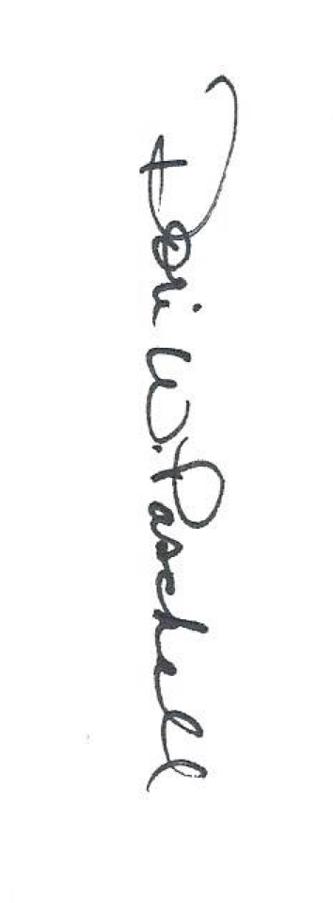
Dori W. Paschall, Chapter Managing Director

Approved by,

Ben Jones
Ben Jones, Chapter President

